Webinar Brief
The role of youth in driving circular economy in agricultural value chains
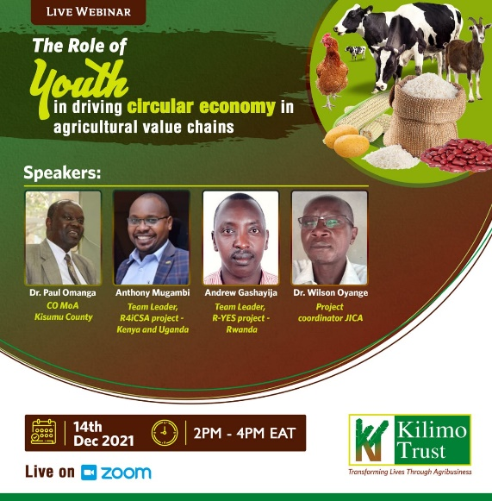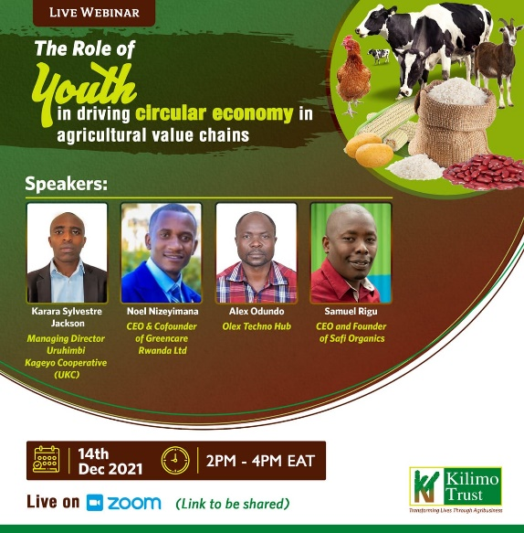
Objective
On Tuesday14th December 2021, a webinar on, “The role of youth in driving circular economy in agricultural value chains” was conducted by Kilimo Trust from 2. p.m to 4. Pm EAT.
The objectives of the webinar were;
- To learn and share knowledge around circular economy particularly looking at the role youth must play to drive the circular economy.
- Lessons from what Kilimo Trust’s R4iCSA and R-YES projects are doing to contribute to regenerative agriculture as well as creation of jobs (including green jobs) for youth in Kenya, Uganda and Rwanda respectively.

Participants
The webinar attracted a maximum attendance of 110 participants without Kilimo Trust staff with a minimum of 100 participants for the whole session. The webinar was also streamed live on our Youtube channel and, a pick of 27 participants was achieved while the minimum through the session was at 20 participants. The webinar looked forward to attracting about 500 participants from across East Africa (Kenya, Uganda, Rwanda, Tanzania, and Burundi) and beyond. Selected speakers at the webinar were expertise with experience of working in the agriculture sector particularly in areas geared towards promoting circular economy. Participants were drawn from public institutions, development organizations and private sector to share their experience, opportunities, challenges, and painting for us the future of circular economy in East Africa and beyond.
Areas for discussion
During the webinar, areas like the role for public institutions in driving the circular economy, what systems are being put in place for youth to take advantage shall be tackled.
We also learnt how the rice value chain is contributing to a circular economy amongst other agricultural value chains.
Kilimo Trust being the lead implementor of two projects contributing towards circular economy regarding recycling rice husks and promoting youth employment in green jobs also shade light on what the R4iCSA and R-YES projects are doing in Kenya, Uganda, and Rwanda.
Youth champions engaged in circular economy from Kenya and Rwanda shared their experiences, challenges, and opportunities in the circular economy to encourage other youth to see potential of job creation in recycling, reusing, and anything climate resilient in the agricultural space.

